Chapter 7, Solution 11.

For t<0, we have the circuit shown below.
4 Ω 4H
+
_

4 Ω
24 V 8 Ω

4H

i_{o}

4 Ω
6 A 4 Ω 8 Ω

4||4= 4x4/8=2
i_{o}(0–) = [2/(2+8)]6 = 1.2 A

For t >0, we have a source-free RL circuit.
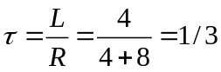 thus,
i_{o}(t) = 1.2e^{–3t} A.

